* Step 1: Python installation and set up
  + Download python from the main website: <https://www.python.org/downloads/>
  + Click on Python.exe when finished to start installation
  + Choose path for the installation and check environment variable checkbox then skim towards the end to finish downloading
  + In your computer Search Bar, search for environment variable and choose “Edit the system environment variables” to run python command in cmd or VS Code terminal

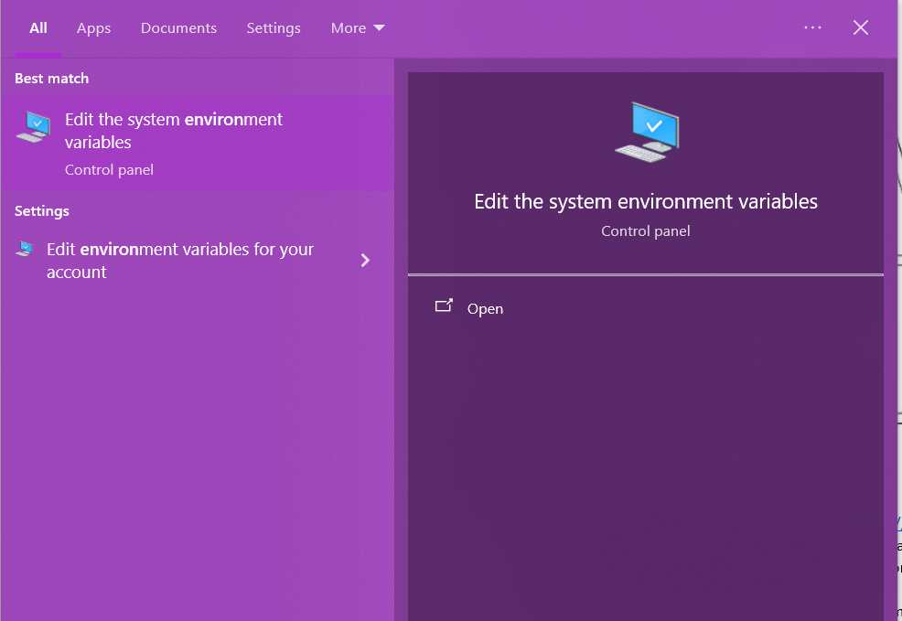

* + Choose environment variables in Advanced tab and choose Path in system variables

|  |  |
| --- | --- |
|  |  |

* + Add path for the Scripts folder of the location you install Python (this is to run “pip install” later on)

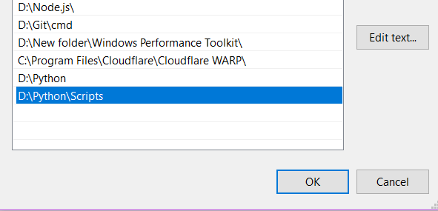

* Step 2: Installing necessary libraries

Within cmd or VS Code terminal, type these commands to install required libraries to run the code:

* + pip install opencv-python
  + pip install torch torchvision torchaudio
  + pip install “numpy<2”
  + pip install scikit-learn
* Step 3: Run the code

After setting everything, run the code using said commands when inside valid terminal

* cd “<project folder>/AVSS2019/src/Demo”
* python demo.py “<video path>” “<ground truth file path>”